Final Project Report
Pipelined IEEE-754 Double-Precision Floating-Point Multiplier
Operating Frequency: 2.0 GHz (Clock Period = 0.5 ns)
學號: 614410105 姓名: 劉宇軒

Architecture & Algorithm

1.1 IEEE 754 雙精度浮點數格式回顧
數值格式為 IEEE 754 double precision，每筆數值固定為 64 bits，欄位定義依下表：
欄位 | 寬度 | 意義
Sign (s) | 1 bit | 0 為正、1 為負
Exponent (e) | 11 bits | bias = 1023
Fraction (f) | 52 bits | 尾數的小數部分

normal number 的數值為： value = (−1)s × 1.f × 2(e−1023)
依 e、f 之組合分類為以下五種case，硬體設計時須個別處理：
類別 | biased exp (e) | fraction (f) | 數值意義
Zero | 0 | 0 | ±0
Subnormal | 0 | ≠ 0 | (−1)ˢ × 0.f × 2⁻¹⁰²²
Normal | 1 ~ 2046 | 任意 | (−1)ˢ × 1.f × 2^(e−1023)
Infinity | 2047 | 0 | ±∞
NaN | 2047 | ≠ 0 | Not a Number

# 對 Subnormal 採 Flush-To-Zero (FTZ) 處理

1.2 浮點數乘法演算法
給定兩個數值 A、B，乘法結果 Z = A × B 由以下三組運算構成：
- Sign 運算：s = s_a XOR s_b
- Exponent 運算：e = e_a + e_b − 1023 (扣掉多一次的 bias)
- Mantissa 運算：m = (1.f_a) × (1.f_b) (53-bit × 53-bit)

Round-to-Nearest-Even 規則
下方表列 round_up 條件，其中 G 為 guard bit、 S 為 sticky bit：
條件 | 捨入方向 | 說明
G = 0 | Round down | 小於 1/2 ，截斷
G = 1 且 (S=1 或 LSB=1) | Round up | >= 1/2 但需 round to even
G = 1 且 S=0 且 LSB=0 | Round down | Round-to-even 之 tie 情況

1.3 53×53 尾數乘法器拆解 (27 × 26 Split)
將 53-bit 尾數從中拆成「上 27 bits + 下 26 bits」兩段：
m_a = {a_h[26:0], a_l[25:0]}, m_b = {b_h[26:0], b_l[25:0]}
乘積依據分配律展開為四項：
Partial product | size | 位移權重
pp_hh = a_h × b_h | 27 × 27 → 54 bits | × 2⁵²
pp_hl = a_h × b_l | 27 × 26 → 53 bits | × 2²⁶
pp_lh = a_l × b_h | 26 × 27 → 53 bits | × 2²⁶
pp_ll = a_l × b_l | 26 × 26 → 52 bits | × 2⁰

1.4 FSM 與 8 pipeline stages
FSM (state[1:0]，0=LOAD、1=COMP、2=OUT)：

Stage | 行為
C1 | sign / exp / fraction 拆出；implicit 1 補回；ZERO / INF / NaN 偵測
C2 | Sign XOR；e_sum = e_a + e_b − 1023；mantissa切成上 27 bits + 下 26 bits
C3 | Partial product：pp_hh (27×27)、pp_hl (27×26)、pp_lh (26×27)、pp_ll (26×26)
C4 | pp_mid = pp_hl + pp_lh
C5 | upper_combo = pp_hh + pp_mid[53:26]；lower_combo =(pp_mid[25:0] + pp_ll
C6 | 合併成 prod_full；正規化 (leading 1)；產出 mant、guard、sticky、e_norm
C7 | Round-to-Nearest-Even：round_up = G & (S | LSB)；mantissa overflow則右移並 e_final += 1
C8 (組合) | Special-case 優先 ； 64-bit pack

2. Test

2.1 self checking

real_Z = real_A * real_B;

C = $realtobits(real_Z);

可得到任意輸入對應的乘法結果

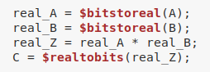

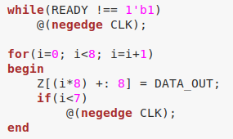

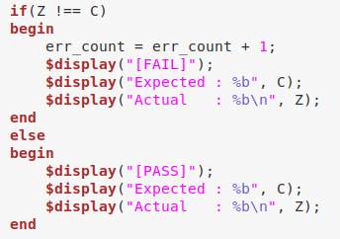

2.2 test pattern

透過 {$random, $random} 產生 64-bit 浮點數作為test pattern，每筆測資皆透過 if (Z !== C) err_count++ 自動比對。模擬結束時 testbench 依據 err_count顯示simulation fail/pass

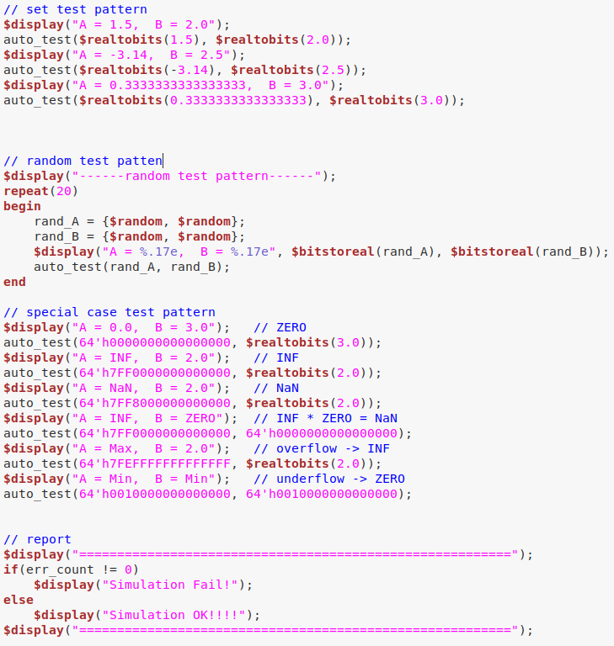

2.3 Special Case Test
針對下列 special case 設計 test pattern，與預期結果比對：

測試項目 | 輸入 A × B | 預期輸出 (IEEE-754) | 結果
Zero | 0.0 × 3.0 | 0 | PASS
Infinity | Inf × 2.0 | Inf | PASS
NaN | NaN × 2.0 | NaN | PASS
Inf × Zero | +Inf × 0.0 | NaN | PASS
Overflow | DBL_MAX × 2.0 | Inf | PASS
Underflow | min_normal × min_normal | 0 (Flush-To-Zero) | PASS

3. Synthesis
- timing report
Timing slack = 4ps
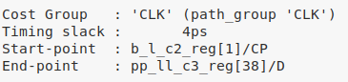
- area report
total area = 8145.088
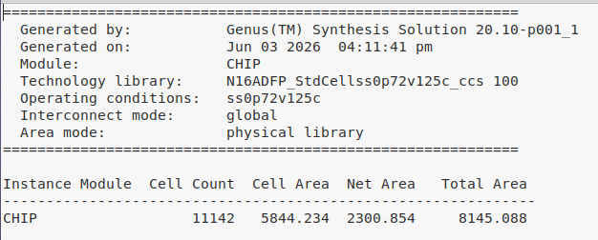

4. APR
- chip size
Die = 133.29 x 131.136
Core width = 121.23 - 12.06 = 109.17
Core height = 119.136 - 12.0 = 107.136
Core area = core width x core height =109.17 × 107.136 ≈ 11,694.4

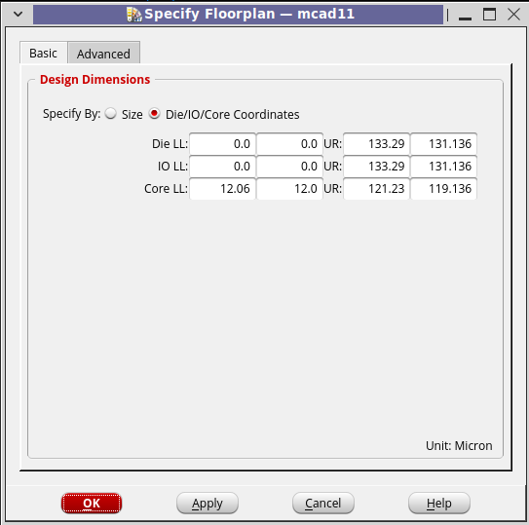
- postRoute
  - setup time WNS = 0.064ns

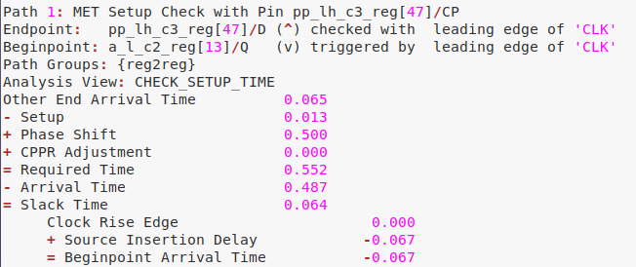
  - hold time WNS = 0.017ns
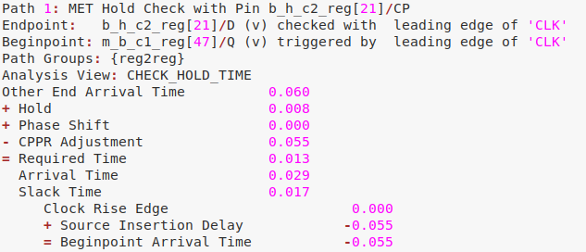
- total power
Internal power = 11.08
Switching power = 4.941
Total power = 18.09
Leakage power = 2.068
- IR drop analysis
data range: <0.00 mV to >3.71mV

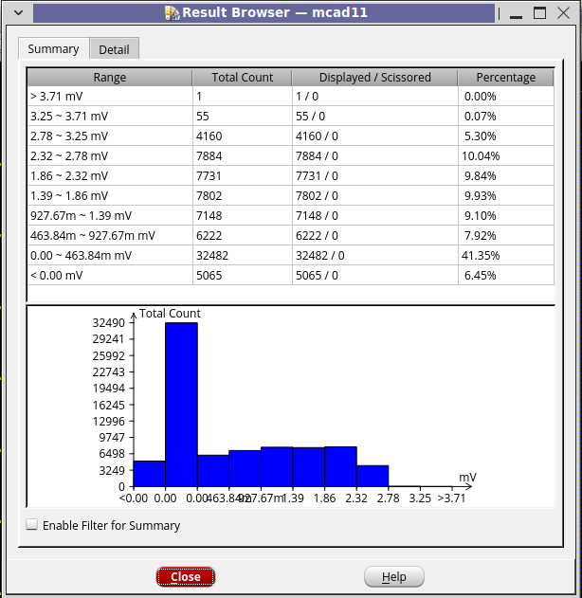

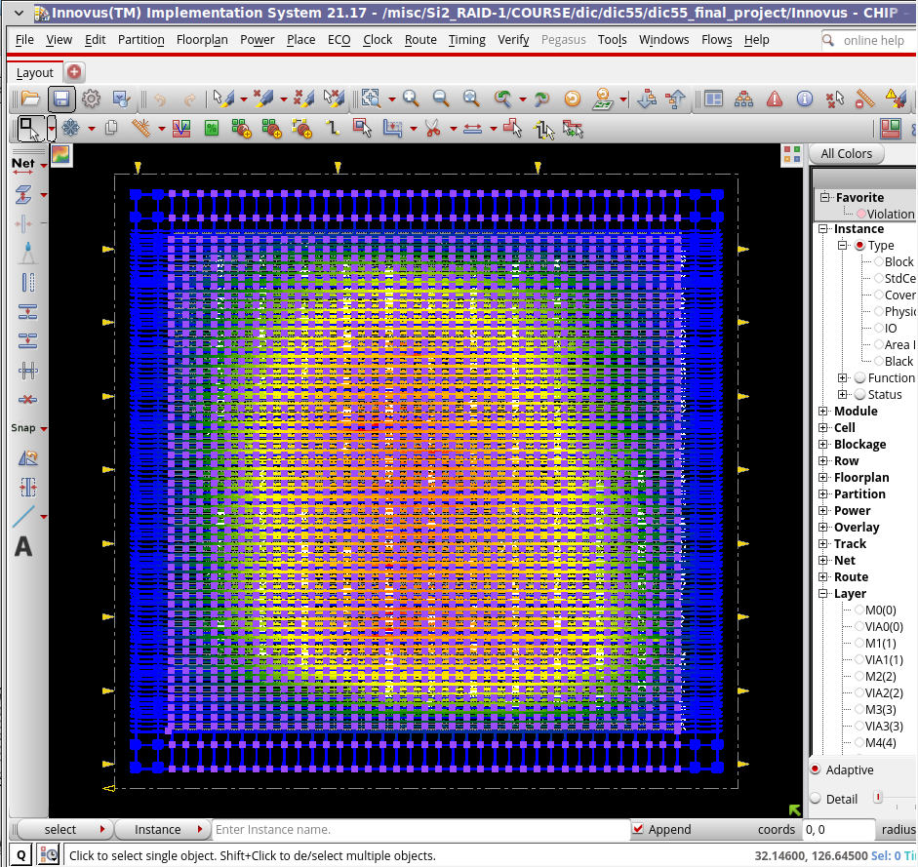

5. DRC & LVS
- DRC PASSED
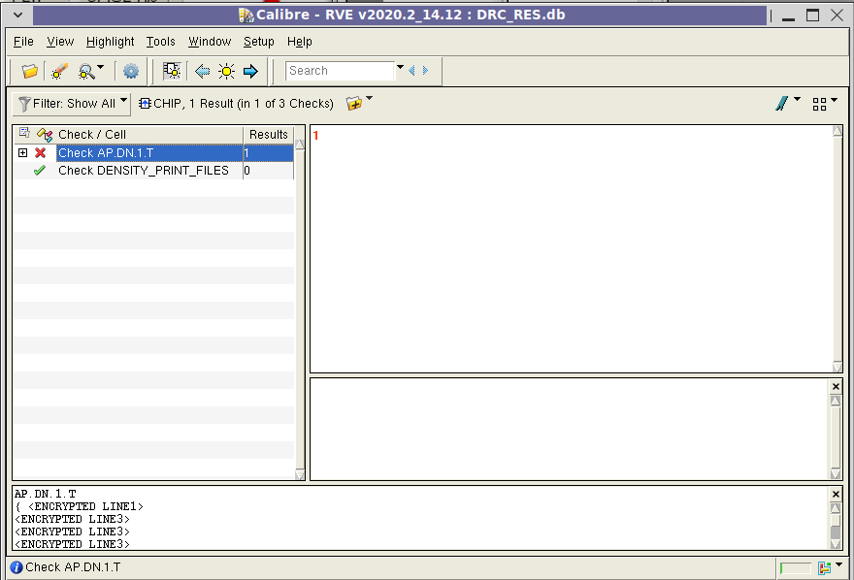

- LVS PASSED
